MATHS  Decimals and percentages  Measurement – converting between units, perimeter, area and volume  Geometry – 3D shapes, angles, polygons, position and direction  Statistics – line graphs, tables and timetables |  |  | ENGLISH  Letter writing  Story writing – pirate adventure  Newspaper Article – World War I  Opportunities for creative writing |  | GUIDED READING  Floodland by Marcus Sedgwick.  War Horse by Michael Morpurgo.
 |  |  | SCIENCE  Living things and their habitats:  - Describe the differences in the life cycles of mammals, amphibians, insects and birds  - Describe the life process of reproduction in some plants and animals  Animals including humans:  - Describe the changes as humans develop to old age |  | HISTORY  How has the River Yeo shaped Yeovil?  How did WWI start?  Why did Indians fight in World War I?
PERSONAL DEVELOPMENT  Communicating Effectively  The digital world  My Body Changes  The Human Body  Junk Food  Nutritional Values |  | RE  What do Christians think God is like?  How do Christians practice unconditional love known as agape? |  |  | GEOGRAPHY  How does the River Yeo change along its course?  How do maps work?  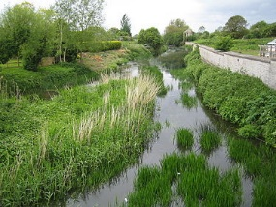
PE  Striking and fielding  Athletics | ART/DT  Drawing  Self-led project |  |  | MUSIC  Keyboard  Classical Music (listening)
 |  |  |  | FRENCH  Brothers and sisters, family members, describing appearance, classroom instructions | 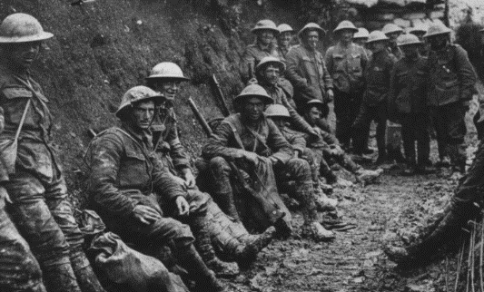
OUR CORE VALUES  Expression  Pride |  |  |  | COMPUTING  Game Creator  Concept maps

