MATHS  Multiplication and Division  Multiply up to a 4-digit number by a 2-digit number.  Divide up to a 4-digit number by a 1-digit number, with or without remainders.  Fractions  Multiply both unit and non-unit fractions by an integer  Calculate a fraction of a quantity.  Decimal and percentages  Find equivalent fractions, decimals and percentages.  Order and compare fractions, decimals and percentages. |  |  |  |  | READING  Holes by Louis Sachar  Journey to the River Sea by Eva Ibbotson  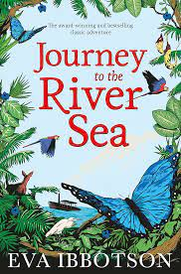
ENGLISH  Integrity biography  Greece persuasive advert  Greek myth  Information text on the Maya  Adventure story  Letter from the Forgotten Territories |  |  | SCIENCE  Earth and Space  · Describe the movement of the Earth, and other planets, relative to the Sun in the solar system  · Use the idea of the Earth’s rotation to explain day and night and the apparent movement of the Sun across the sky.  Forces  · Explain that unsupported objects fall towards the Earth because of the force of gravity acting between the Earth and the falling object  · Identify the effects of air resistance, water resistance and friction, that act between moving surface |  | HISTORY  What can historians learn from Ancient Greek artefacts?  What do we know about the achievements of the Maya?
PERSONAL DEVELOPMENT  Responsibility, fairtrade, the digital world and social media. |  | RE  What is Philosophy and how do we discuss it?  Is Humanism a religion? |  |  | GEOGRAPHY  How does the Mississippi river change along its course?  How does our planet interact with our sun?
PE  Invasion games  Gymnastics | ART/DT  Jewellery design  Artist study – Maude Lewis  Solar system models |  |  | MUSIC  Introduction to the keyboard  Blues
 |  |  |  | FRENCH  Adjectives to describe classroom objects.  Favourite subjects-school timetable, writing and talking about which subjects they enjoy learning and why. | 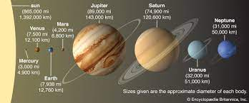
OUR CORE VALUES  Integrity  Determination |  |  |  | COMPUTING  Databases and online safety  Coding

